Multiple choice section

|  |  |  |  |  |  |  |  |  |  |  |  |
| --- | --- | --- | --- | --- | --- | --- | --- | --- | --- | --- | --- |
| Question | 1 | 2 | 3 | 4 | 5 | 6 | 7 | 8 | 9 | 10 | 11 |
| Answer | B | D | B | A | C | C | D | D | C | C | B |

Question 1 [9.2]

B

Put the data in order.

4 4 5 6 8

The median is the value in the middle: 5

Question 2 [9.3]

D

Pies 25%

Lions 5%

Total 30%

Question 3 [9.7]

B



Question 4 [9.4]

A

Sector graph is the best.

Question 5 [9.2]

C

Add up the values and divide by 7.

 = 6

Question 6 [9.1]

C

Identify the results in the given range.

16 18 20 15 18 19

There are six results.

Question 7 [9.7]

D

Pr(Victor wins) =  × 100% ≈ 55%

Question 8 [9.4]

D

46% of 360° = ≈ 166°

Question 9 [9.5]

D

You can be certain it rained only when the water level rises. This occurred in Weeks 1, 5 and 8

Question 10 [9.4]

C

Agriculture is the second section (15%).

Transport is the third section (14%).

This gives a total of 29%.

Question 11 [9.2]

B

1, 1, 2, 2, 3, 3, 3, 4, 4, 5

There are more 3s than any other number.

Multiple-choice total marks: 11

Short answer section

Question 12 3 marks [9.1]

(a) The mean of a data set is found by adding together all the results and dividing by the number of results.

(b) The probability of an event is found by dividing the number of successful outcomes by the total number of outcomes.

(c) If we record the colour of cars in a car park we are dealing with categorical data.

Question 13 2 marks [9.1]

Continuous numerical data is associated with things that are measured, such as length and time. Any value is possible across the whole range of values. An example would be the length jumped by each of the students in the long jump event. Discrete numerical data has a countable number of outcomes, but they are not necessarily whole number values. The number of brothers and sisters that each student in the class has is an example of discrete data.

Question 14 10 marks [9.3]

(a) (i) Mean:  
 =  ≈ 4.8

(ii) Median =  = 4.5

(iii) Mode = 7

(iv) Range = 7 – 2 = 5

(b) (i) Mean =  ≈ 5.1. The mean has increased by 0.3  
(ii) The median remains the same.  
(iii) There are now two modes: 4 and 7.  
(iv) Range = 12 – 2 = 10. The range has increased by 5.

Question 15 4 marks [9.5]

(a) Joanie spent $50 at 10 am.

(b) Joanie withdrew $100 at 3 pm.

(c) Joanie had $40 in her wallet from 11 am until 1.30 pm: 1 hours.

(d) Joanie had less than $80 in her wallet from 10 am until 2 pm: 4 hours.

Question 16 4 marks [9.3]

(a)

|  |  |
| --- | --- |
| STEM | LEAF |
| 0 | 5 6 8 9 |
| 1 | 0 1 2 4 5 9 9 |
| 2 | 0 2 5 5 6 6 7 |
| 3 | 1 7 8 |
| 4 | 0 3 4 |

(b) Median =  = 21  
Range = 44 – 5 = 39  
On average students in the class went to the cinema 21 times. The spread of data is very large with a difference of 39 between the highest number of movies seen and the lowest.

Question 17 4 marks [9.4]

(a)  × 360° ≈ 260°

(b) 1 cm ↔ 200  
17.5 cm ↔ 3500  
Make the total length 17.5 cm i.e. 175 mm.  
1 mm ↔ 20  
962 ÷ 20 = 48.1 ≈ 48 mm

Question 18 5 marks [9.6]

Brisbane is, on average, 6 to 8 degrees warmer than Hobart throughout the year with Hobart taking longer to warm up in summer. Brisbane’s median average monthly temperature is 26 °C with a range of 9 °C. Hobart’s median average monthly temperature is 17.5 °C (cooler by 8.5 °C) with a range of 10 °C (slightly higher variation).

Question 19 7 marks [9.7]

(a) Pr(15) = 

(b) Pr (5, 10, 15, 20) = 

(c) Pr (9, 18) = 

(d) Pr (2, 3, 5, 7, 11, 13, 17, 19) = 

(e) Pr (3, 6, 9, 12, 15, 18) = 

Short answer total: 39

Extended answer section

Question 20 7 marks [9.1, 9.3, 9.4]

(a) The data is continuous.

(b)

|  |  |  |
| --- | --- | --- |
| Class interval | Tally marks | Frequency |
| 11.5−<12.0 | ⏐⏐ | 2 |
| 12.0−<12.5 |  | 0 |
| 12.5−<13.0 | ~~⏐⏐⏐⏐~~⏐⏐⏐ | 8 |
| 13.0−<13.5 | ~~⏐⏐⏐⏐~~ | 5 |
| 13.5−<14.0 | ⏐⏐⏐⏐ | 4 |
| 14.0−<14.5 | ~~⏐⏐⏐⏐~~⏐ | 6 |
|  |  | **25** |

(c)

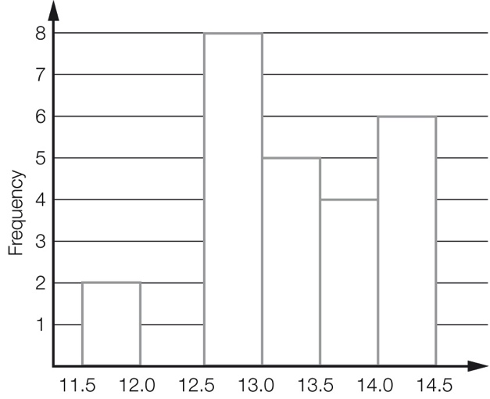

(d) Better than 13.0 seconds:  
 =  =  = 40%

Question 21 6 marks [9.2, 9.6]

For comparison, a summary of the historical data is:

|  |  |  |  |
| --- | --- | --- | --- |
| Total | Median | Highest | Lowest |
| 649 | 53 | 66 | 47 |

Answers will vary – the actual values are given below.

|  |  |  |  |  |  |  |  |  |  |  |  |
| --- | --- | --- | --- | --- | --- | --- | --- | --- | --- | --- | --- |
| J | F | M | A | M | J | J | A | S | O | N | D |
| 45 | 40 | 41 | 50 | 47 | 47 | 45 | 51 | 53 | 59 | 63 | 64 |

The historical data shows higher rainfall on average (4 mm more per month) with less variation from one month to another.

Question 22 8 marks [9.6, 9.7]

(a) 10 + 8 + 4 + 2 + 1 = 25  
Could make the graph 12.5 cm i.e. 125 mm high. (Other answers possible.)

(b) 1 cm ↔ 2  
4 cm ↔ 8  
‘Dog’ would be 4 cm i.e. 40 mm high.

(c) Pr(cat) =  = 

(d) 12 + 5 + 3 + 1 + 7 = 28  
 × 12.5 cm = 3.125 cm ≈ 31 mm

(e) Whichever has the higher proportion will have the greater height since the total heights are the same.  
7A:  =  = 0.4  
7B:  =  ≈ 0.43  
‘Cat’ would be a greater height on the 7B graph.

Question 23 9 marks [9.7]

(a)

|  |  |  |  |  |  |  |
| --- | --- | --- | --- | --- | --- | --- |
|  | 1 | 2 | 3 | 4 | 5 | 6 |
| **R1** | (R1, 1) | (R1, 2) | (R1, 3) | (R1, 4) | (R1, 5) | (R1, 6) |
| **R2** | (R2, 1) | (R2, 2) | (R2, 3) | (R2, 4) | (R2, 5) | (R2, 6) |
| **G1** | (G1, 1) | (G1, 2) | (G1, 3) | (G1, 4) | (G1, 5) | (G1, 6) |
| **G2** | (G2, 1) | (G2, 2) | (G2, 3) | (G2, 4) | (G2, 5) | (G2, 6) |
| **B** | (B, 1) | (B, 2) | (B, 3) | (B, 4) | (B, 5) | (B, 6) |

(b) Pr(B, even) = 

(c) Pr(R, even) = 

(d) The game is not fair because Terry has twice the chance of winning that Steve has.

(e) Students will provide their own answer, but a sample game would be:  
Steve wins if green and odd and Terry wins if red and even.

Extended answer total: 30

TOTAL test marks: 80